***SIGNALS AND SYSTEMS***

Signals

A signal is a set of information or data

1.1 Size of a Signal

a. Signal Energy

Ef = 2dt

f(t) can be complex signal (a + jb)

b. Signal Power

Pf = 2(t)dt

T is period

**Example**

(a)

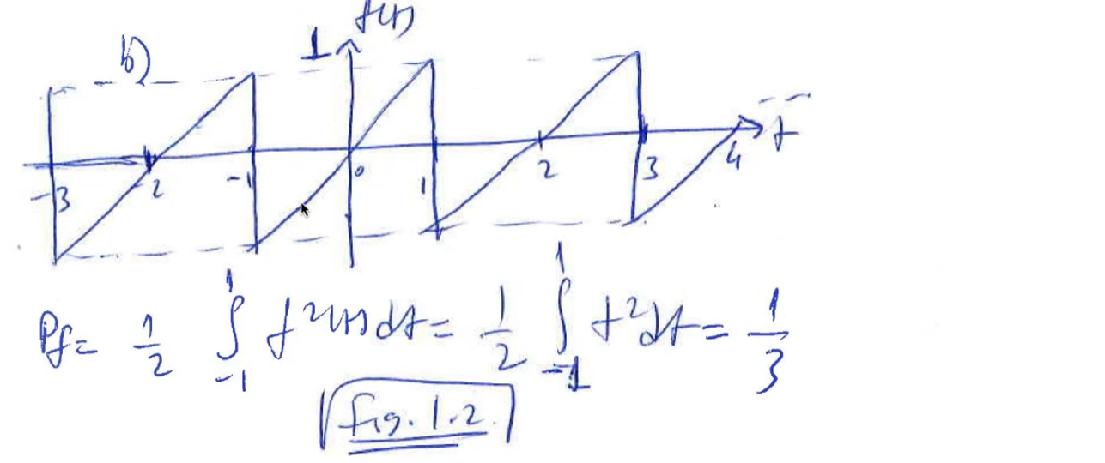(b)

equation of this signal is t

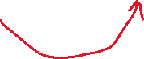

1.2 Classification of Signals

1. Continuous-time and discrete-time signals
2. Analog and digital signals
3. Periodic and aperiodic signals
4. Energy and power signals
5. Deterministic and probabilistic signals

1.2.1 Continuous-time and Discrete-time Signals

CONTINUOUS-TIME (CT) SIGNALS: A signal that is specified for every value of time t.

DISCRETE-TIME (DT) SIGNALS: A signal that is specified at discrete values of t.

CT: for every value of t, there is a value f(t)

DT: f(n) has value only on discrete values of n

1.2.2 Analog and Digital Signals

ANALOG SIGNAL: A signal whose amplitude can take on any value in a continuous range

DIGITAL SIGNAL: A signal whose amplitude can take on only a finite number of values

a 🡪 for every f(t) value, there is a time

b 🡪 there is no f(t) for every t, it takes only 2 values: -1 and 1 (or can be thought as bit 0 and bit 1)

1.2.3 Periodic and Aperiodic Signals

PERIODIC SIGNAL: A signal f(t) is said to be periodic if for some positive constant T0 (period),

f(t) = f(t + T0) , for all t -------> condition for periodicity

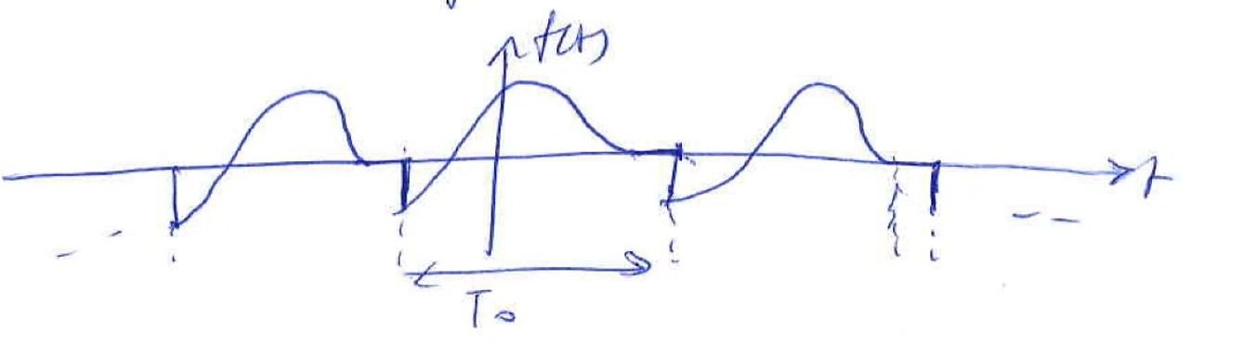



CAUSAL SIGNAL: f(t) = 0, t < 0

1.2.4 Energy and Power Signals

ENERGY SIGNAL: A signal with finite energy

Its energy was 8 which is finite

POWER SIGNAL: A signal with finite and non-zero power

Its power was 1/3 which is finite and non-zero.

1.2.5 Deterministic and Random Signals

DETERMINISTIC: A signal whose physical description is known completely, either in a mathematical form or a graphical form

I know the behaviour completely for these 2 signals. You can calculate t = 1, t = 1000, … bc you know how it behaves

RANDOM (NON-DETERMINISTIC): A signal whose values cannot be predicted precisely but are known only in term of probabilistic description (mean, average, standard deviation). These are signals that we encountered in our daily lives. Stock value, gold price, etc.

1.3 Some Useful Signal Operations

1.3-1 🡪 Time-shifting

1.3-2 🡪 Time-scaling



1.3-3 🡪 Time-inversion (Time reverseal)

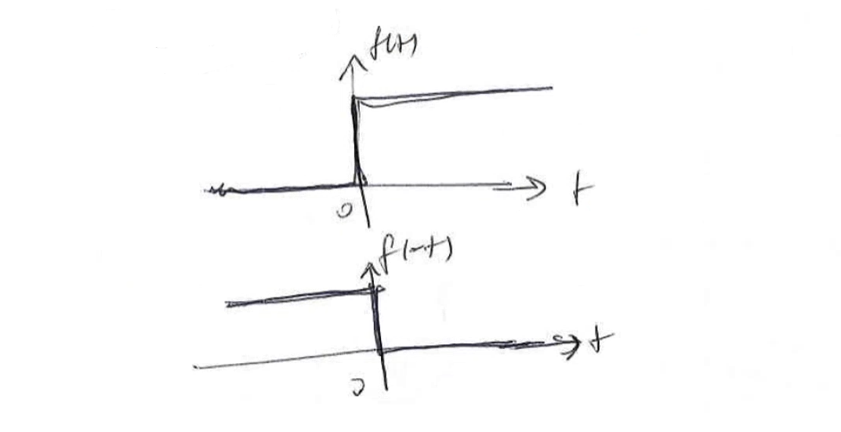

1.4 Some Useful Signal Models

1.4-1 🡪 Unit-step function

1.4-2 🡪 Impulse function

It has value only when t=0, otherwise it is equal to 0

1.4-3 🡪 Exponential function

1.5 Even and Odd Functions

EVEN: f(t) = f(-t)

ODD: f(t) = -f(-t)

Every signal can be expressed in terms of even and odd signal:

f(t) = [f(t) + f(-t)] + [f(t) – f(-t)]

even odd

1.6 Systems

SYSTEMS: They are used to process signals in order to modify or to extract additional   
 information from the signals

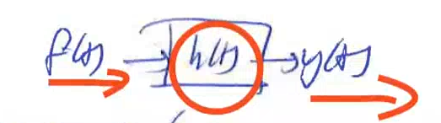

f(t) 🡪 input signal

h(t) 🡪 impulse response, behaviour of the system, it is gonna shape input signal

y(t) 🡪 output signal

1.7 Classification of System

1.7-1 Linear and Nonlinear systems

i) additivity

c1 🡪 e1 and c2 🡪 e2

then for all c1 and c2:

c1 + c2 🡪 e1 + e2

ii) homogeneity

c 🡪 e

kc 🡪 ke

iii) superposition (combine of previous two)

c1 🡪 e1 and c2 🡪 e2

then for all values of constants k1 and k2:

k1c1 + k2c2 🡪 k1e1 + k2e2

*If system satisfies superposition, then system is linear.*

EXAMPLE:

+ 3y(t) = x(t) is it linear?

x1(t) 🡪 h(t) 🡪 y1(t) -------------> k1/ + 3y1(t) = x1(t)

x2(t) 🡪 h(t) 🡪 y2(t) -------------> k2/ + 3y2(t) = x2(t)

+

[k1y1(t) + k2y2(t)] +3[k1y1(t) + k2y2(t)] = k1x1(t) + k2x2(t)

y(t) y(t) x(t)

This form looks like the original form.

When the input x(t) = k1x1(t) + k2x2(t), then the output is y(t) = k1y1(t) + k2y2(t)

Then this system is linear.

In reality most of the systems are non-linear. In order to analyze them in mathematical form, we convert them into linear systems to simplify the analysis.

We only deal with linear systems.

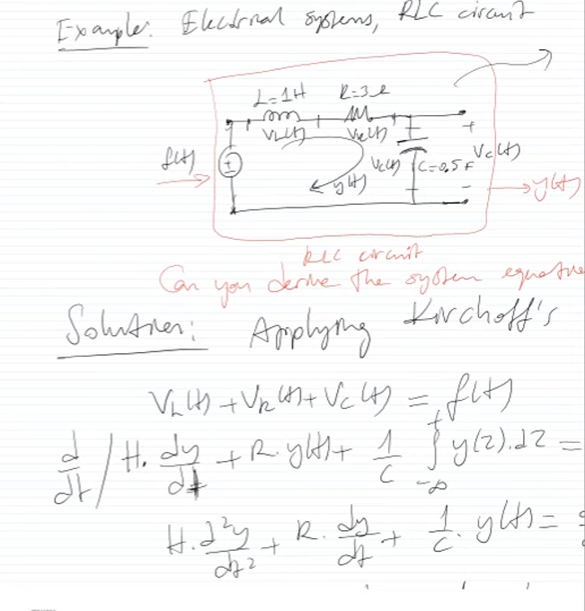

Input is f(t) which is my input voltage and output is y(t) which is current.



Right part of the equation is differential of f(t). Df(t)

d/dt = D

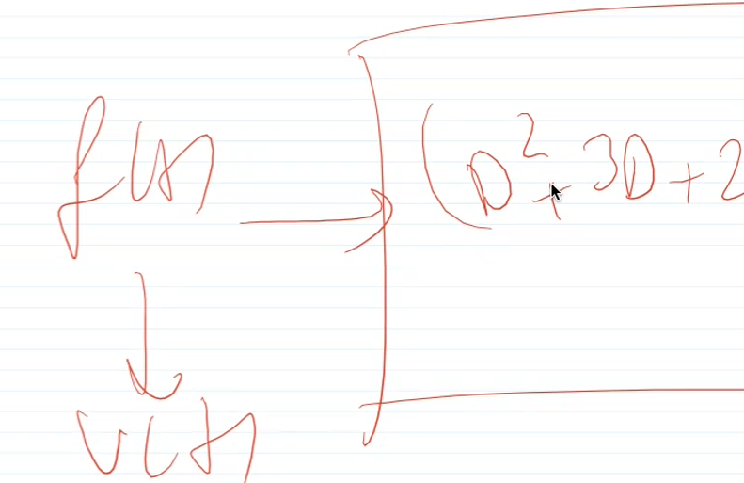

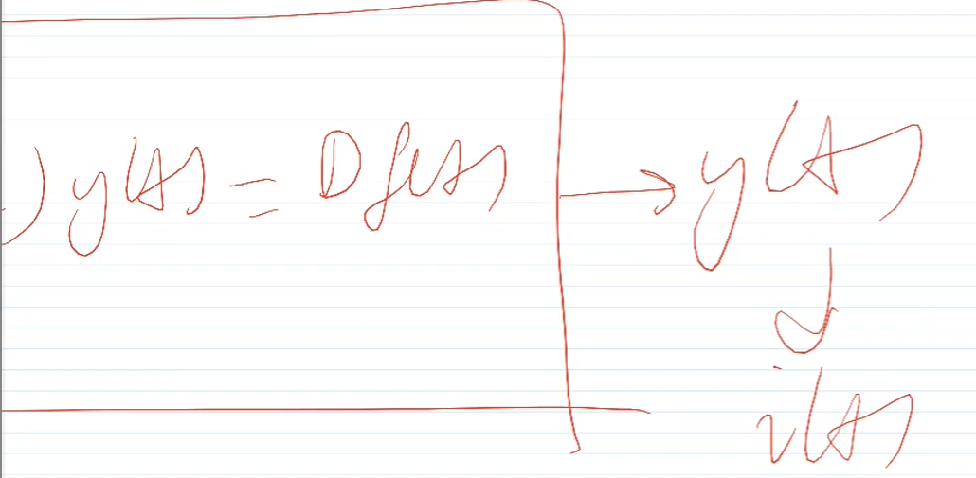

So system equation of this RLC circuit is equal to (D2 + 3D + 2)y(t) = Df(t)